A close up of a sign

Description generated with high confidence

**2017**

**PROJECT: INTERNET RADIO**

**By**

Rasul Ahmed – 1521485  
Arianul Islam – 1522435   
Rafat Hasan Khan – 1731117

Mohaiminul Islam Erai – 1721499

Md. Mahbubur Rahman Akash – 1522439

**INDEPENDENT UNIVERSITY, BANGLADESH**

04th October 2017

Supervisor: **Dr Mahady Hasan**

Table of Contents

1.0 **INTRODUCTION** **3**.

1.1 Background Of The Project: **3.**

1.2 Objectives Of The Project: **4.**

1.3 Scope Of The Project: **4.**

2.0 **Requirement** **5.**

2.2 Hardware **5.**

2.3 Software **5.**

3.0 **Installation** **6.**

3.1 Etcher Burner **6.**

3.2 MobaXterm **7.**

3.3 Raspbian Upgrade **7.**

3.4 MPD &MPC **9.**

3.5 Interfacing Circuit **10.**

4.0 **Configuration** **13.**

4.1 Router Configuration **13.**

4.2 Pi Wifi Configuration **14.**

4.3 MobaXterm Configuration **15.**

4.4 SSH enabling & Audio **17.**

4.5 GitHub Linking & Cloning **19.**

5.0 **Problem & Solution** **20.**

5.1 Problem faced **20.**

5.2 Solution **20.**

6.0 **Completing Radio** **21.**

6.1 Playing and casing **21.**

7.0 **Contact** **22.**

7.1 Email & Other links **22.**

8.0 **Conclusion** **23.**

8.1 Future Development **23.**

8.2 Conclusion **23.**

References: **24.**

THE END **24.**

**1.0 INTRODUCTION**

**1.1 BACKGROUND OF THE PROJECT**

Internet Radio (also **web radio**, **net radio**, **streaming radio**, **e-radio**, **IP radio**, **online radio**) is an audio service transmitted via the Internet. Broadcasting on the Internet is usually referred to as webcasting since it is not transmitted broadly through wireless means.

Internet radio involves streaming media, presenting listeners with a continuous stream of audio that typically cannot be paused or replayed, much like traditional broadcast media; in this respect, it is distinct from on-demand file serving. Internet radio is also distinct from podcasting, which involves downloading rather than streaming.

Internet radio services offer news, sports, talk, and various genres of music—every format that is available on traditional broadcast radio stations. Many Internet radio services are associated with a corresponding traditional (terrestrial) radio station or radio network, although low start-up and ongoing costs have allowed a substantial proliferation of independent Internet-only radio stations.

**1.2 Objective of the Project**

Objective of the project is to stream live links from various stations and create a radio using Raspberry Pi. We mine many live radio station links and check them before linking them up with mpc. We use python software to run the interface of the radio eg: play, stop, next, vol up and down.

**1.3 Scope of the Project**

* Learning Raspberry Pi functions and features. <linux commands>
* Code python inside Raspbian.
* Linking live Stream stations.
* Playing the links using mpc and mpd.

**2.0 REQUIREMENT**

**2.1 Hardware**

1. Raspberry Pi 3
2. Keyboard
3. Mouse
4. Memory Card (4GB Class 10 recommended)
5. Speakers
6. Ethernet Cable (optional if Wi-Fi not available)
7. HDMI
8. Charger cord and cable
9. Laptop/PC

For Switching circuit :  
 1. Switch (4 pcs)  
 2. Soldering machine  
 3. Wires  
 4. Male- Female jumper wires  
 5. Circuit Board

6. 2 LED’s

**2.2 Software**

1. Raspbian (Latest Version Image)
2. Etcher Burner
3. MobaXterm

**3.0 INSTALLATION**

**3.1 Etcher Burner**

*Download Etcher Burner from this link here: <https://etcher.io/>

Install Etcher:

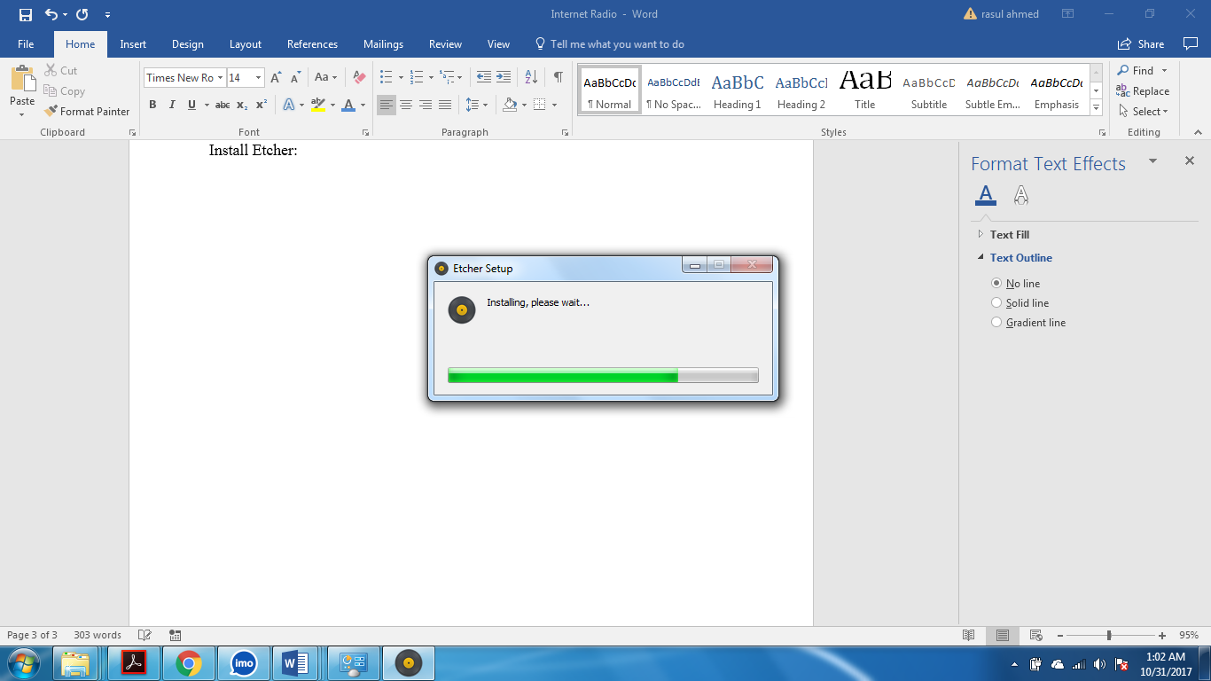

Open Etcher:-

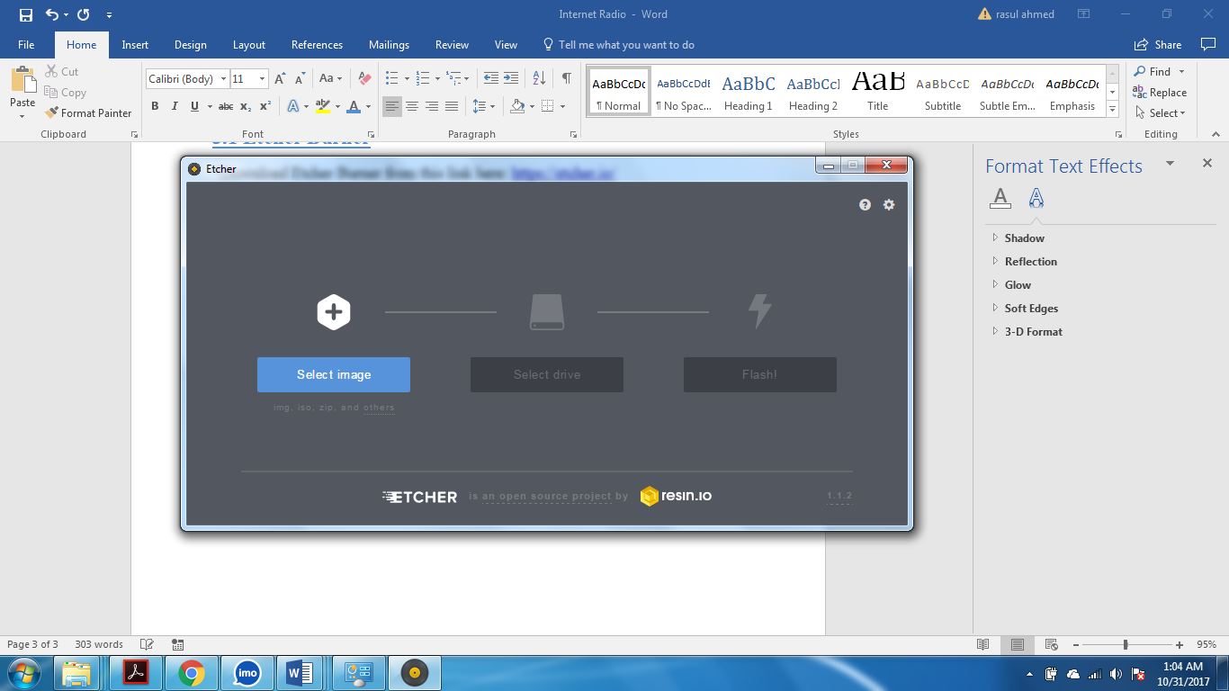

Insert Memory Card and Burn the Raspbian image :

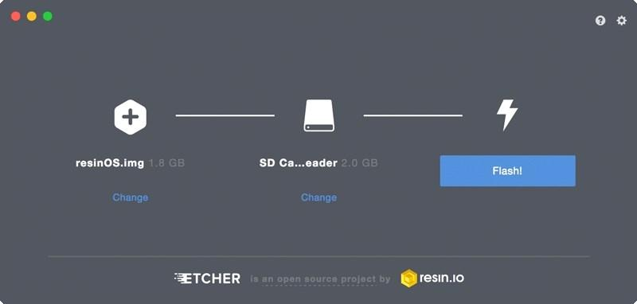

**3.2 MobaXterm**

* Download MobaXterm home edition from the link here: <https://mobaxterm.mobatek.net/download-home-edition.html>

Install MobaXterm:

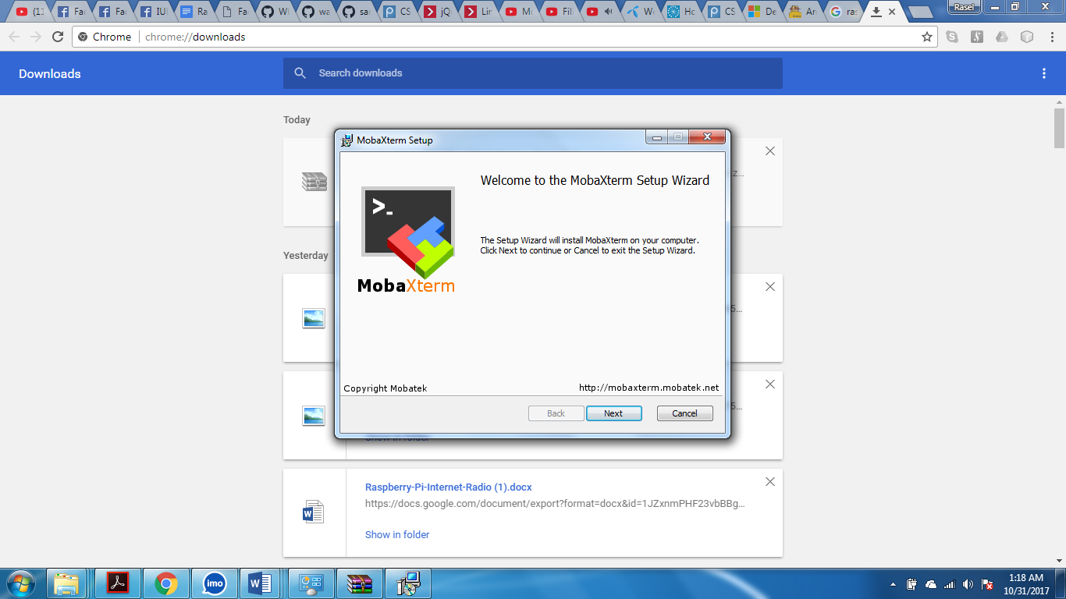

Open MobaXterm:

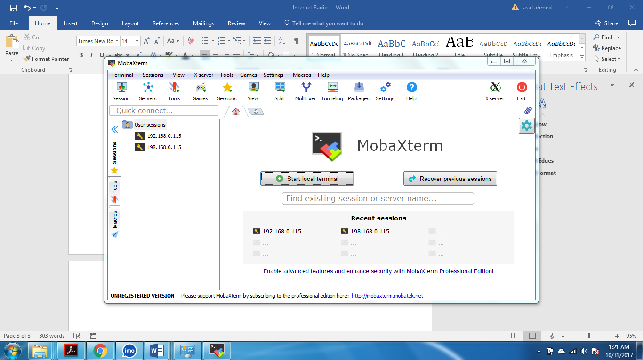

**3.3 Raspbian Upgrade**

Default **Username and Password: username: pi ; password: raspberry**

Load terminal and update all the apps using: “sudo apt-get update”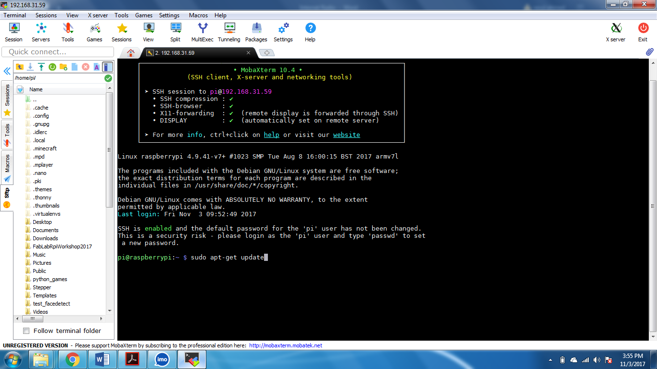

After the update type: “sudo apt-get upgrade”

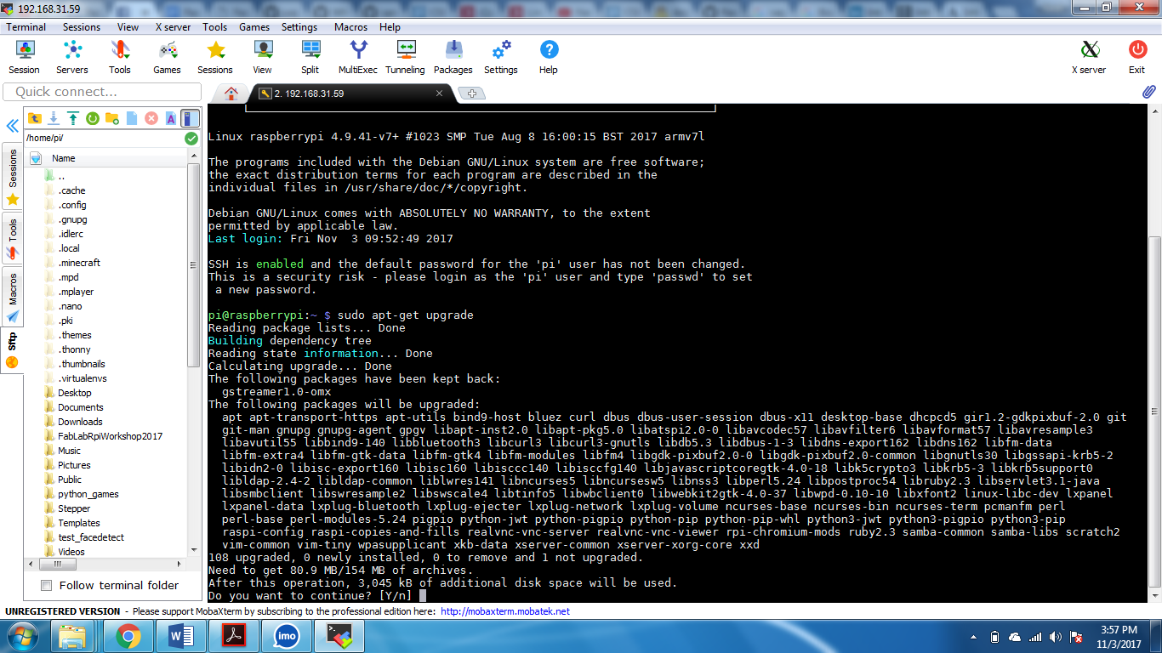

**3.4 MPD & MPC**

Use this command to install Mpd and Mpc: “sudo apt-get install mpd mpc”

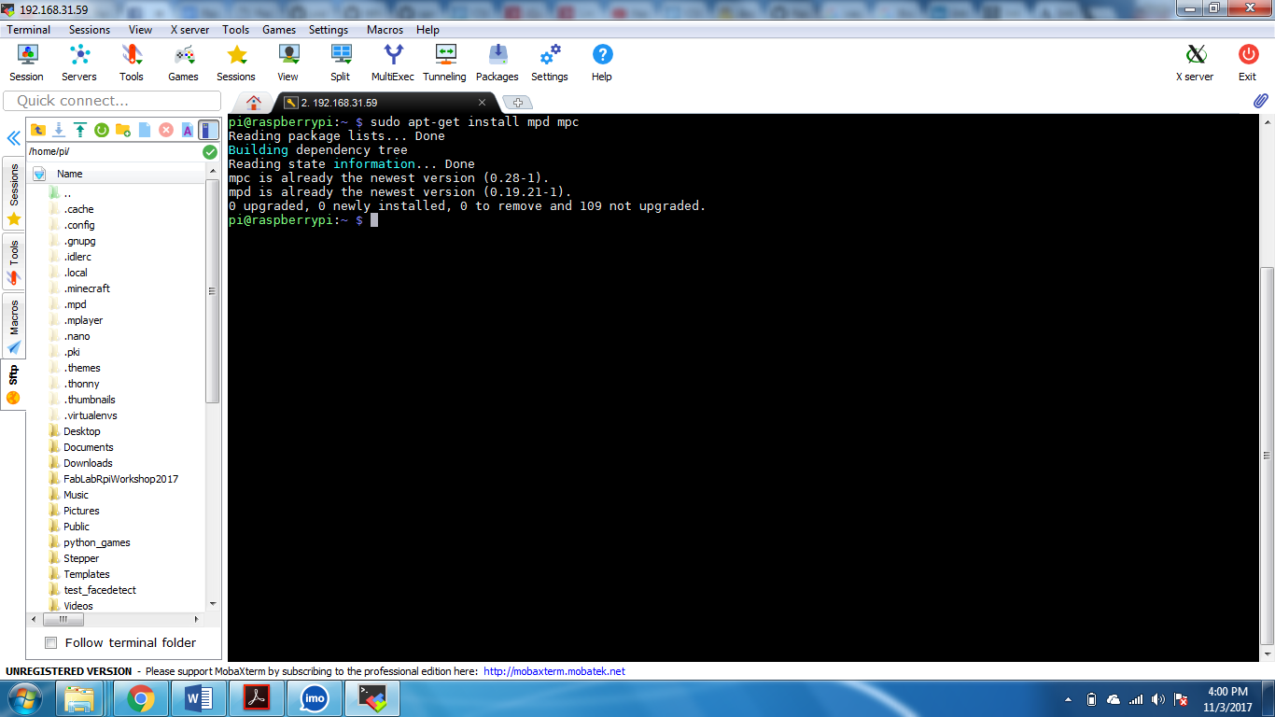

**3.5 Interfacing Circuit**

4 Interfacing switches connected in this pattern and LEDs .

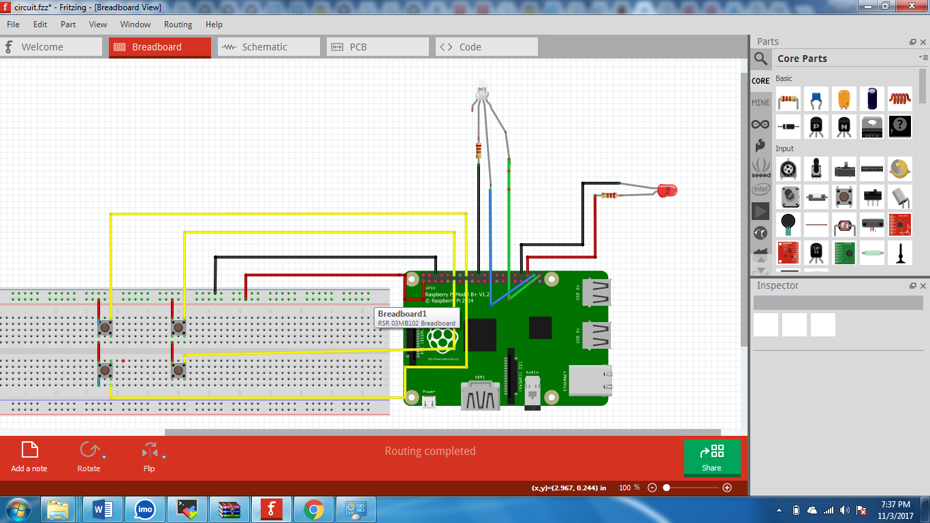

Board size depends on what scale you want the Radio to be, For us its 7cm x 3 cm.

A circuit board

Description generated with high confidence

Swtiches:

1. play/pause
2. next station
3. vol down
4. vol up

A close up of a device

Description generated with high confidence

Raspberry Pi pin Serial:

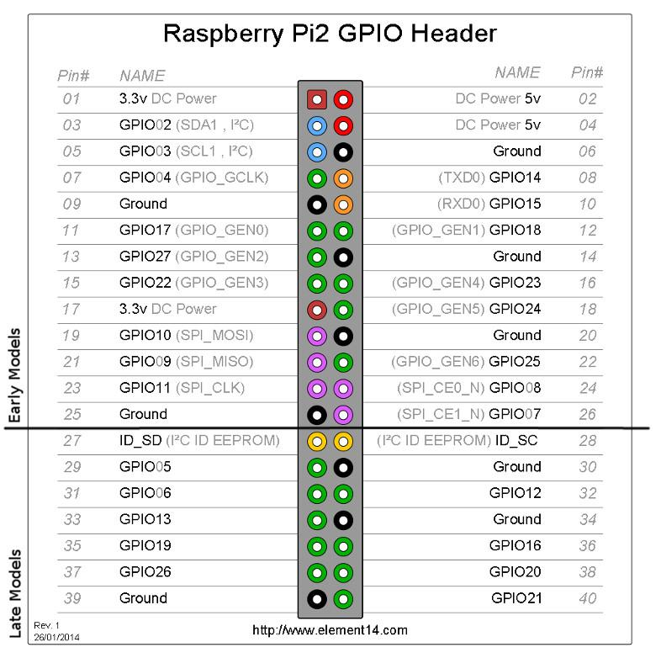

**4.0 CONFIGURATION**

**4.1 Router configuration**

Go to your router link and configure the wifi password:

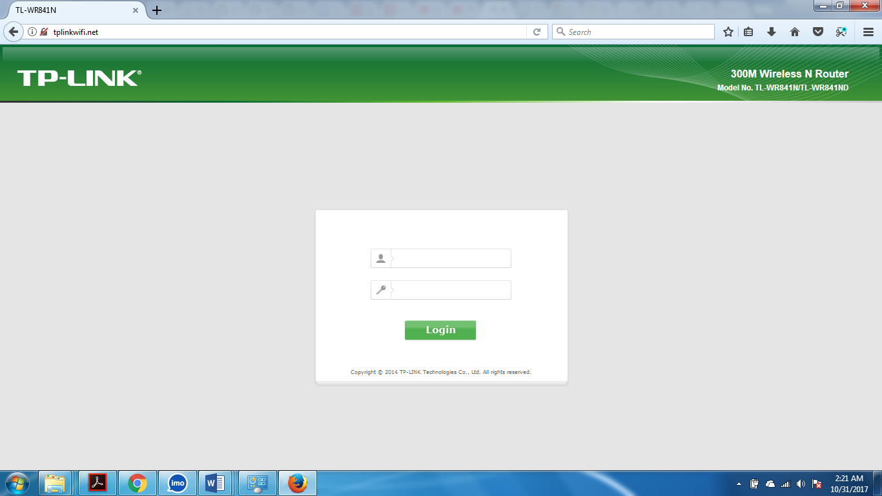

Go to wireless settings and check the wifi password or set a new password:

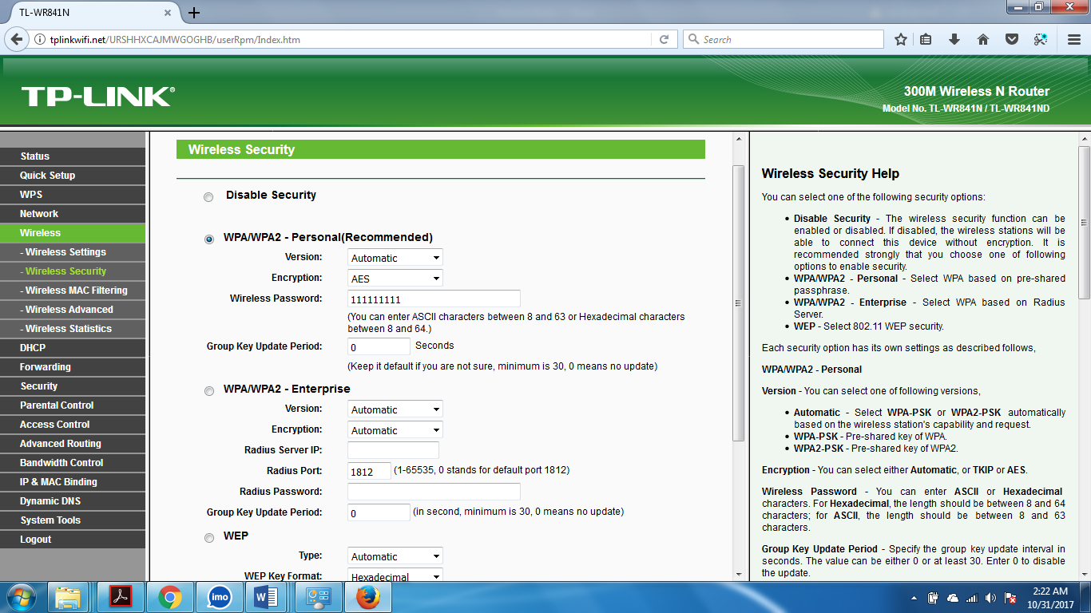

**4.2 Pi Wi-Fi Configuration**

Use Raspbian GUI to navigate to wireless and connect to your Wi-Fi using password.

**A screen shot of a computer

Description generated with high confidence**

**4.3 MobaXterm Configuration**

To config MobaXterm we need to check IP address of the Raspberry Pi.  
 Open terminal in Raspbian and type : “ifconfig”

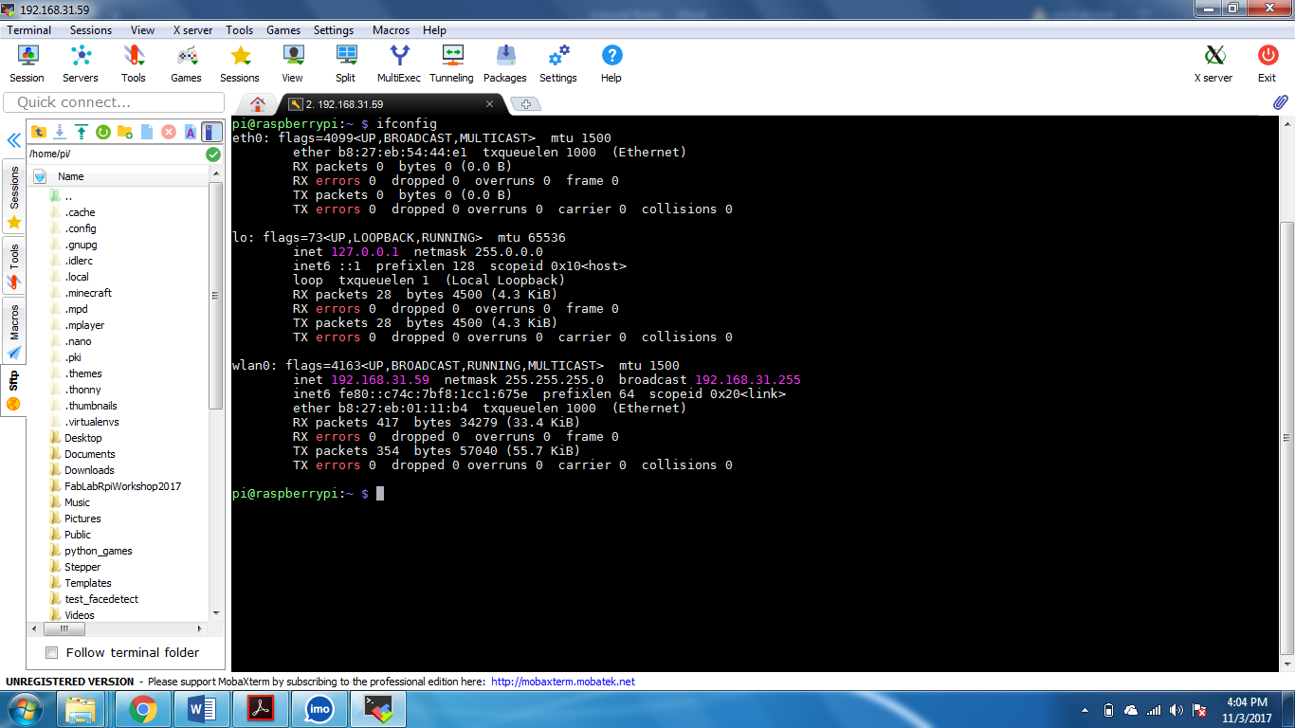  
  
Now open MobaXterm and press session:

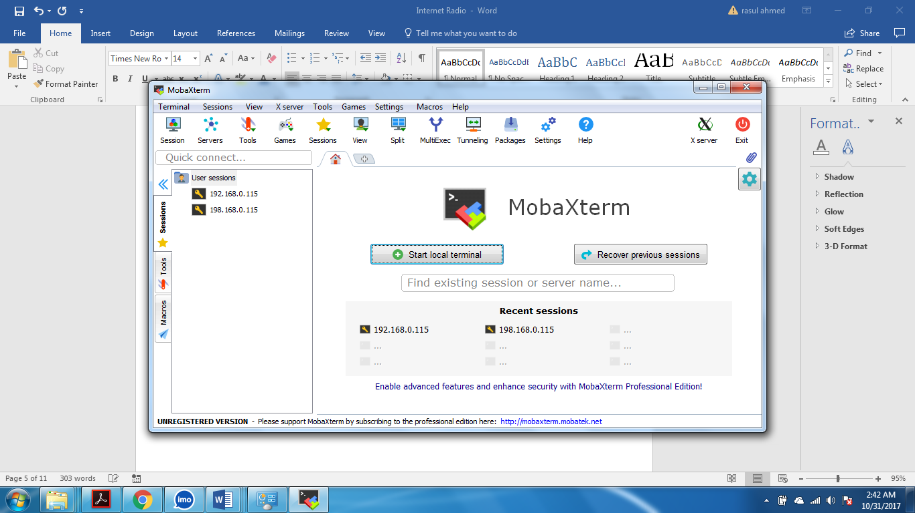

Then Click on SSH:

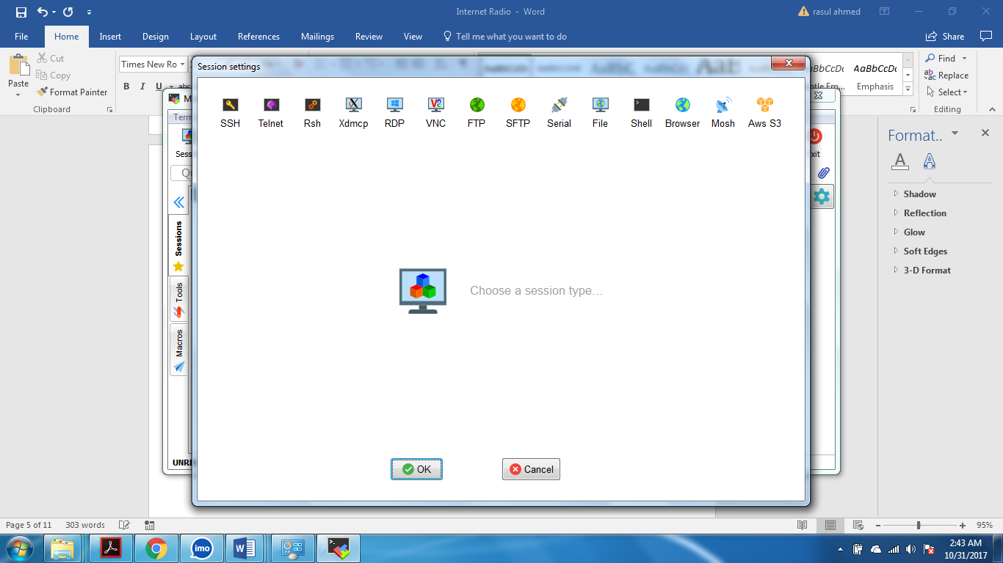

Type the IP Address there and Press OK to complete connection:

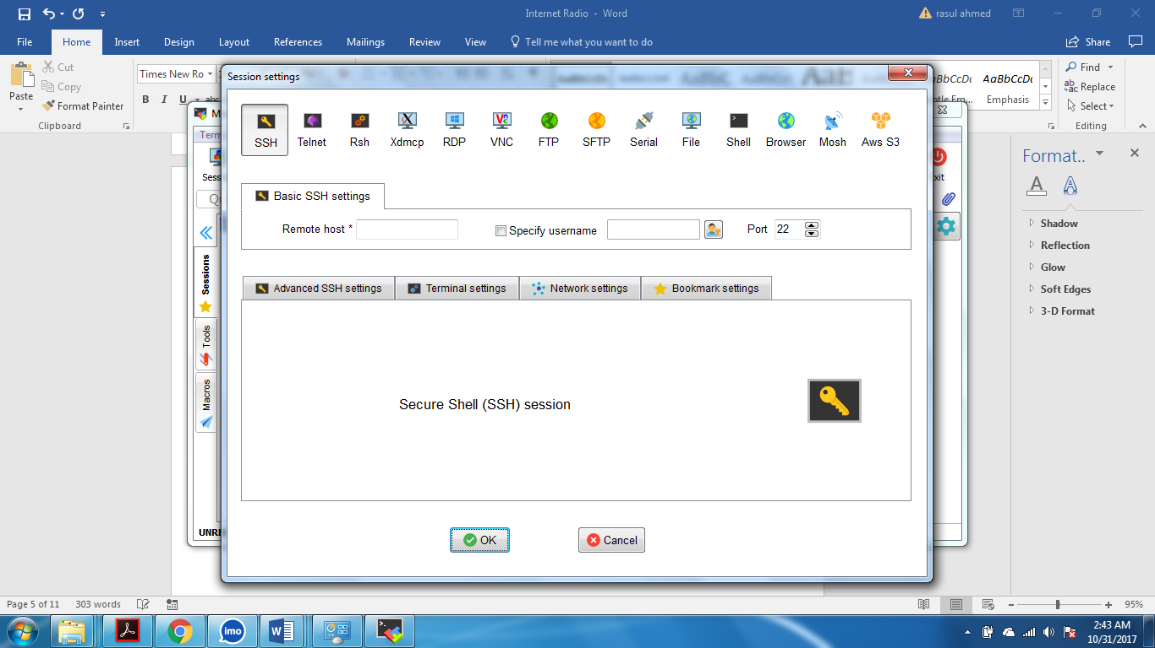

**4.4 SSH Enabling & Audio**

In MobaXterm terminal type: “sudo raspi-config”

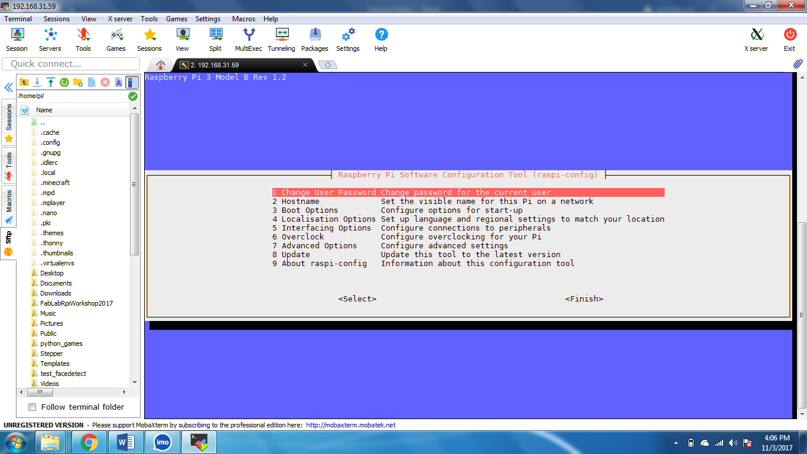

Go to line 5 (Interfacing Option) :  
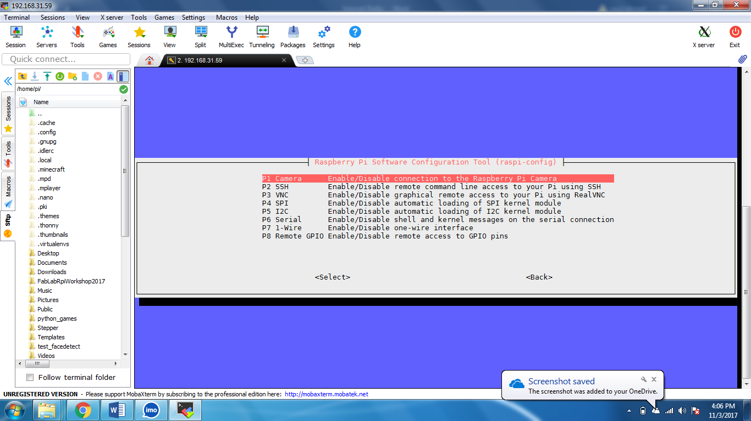

Go to line 2 (SSH) and press Ok and confirm:

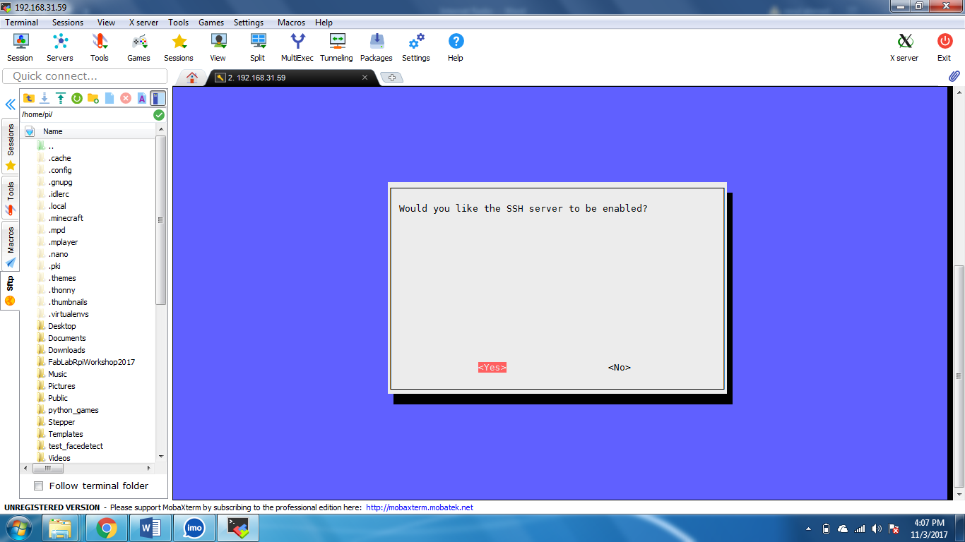

Repeat 4.4 and go to line 7 (Advance options):

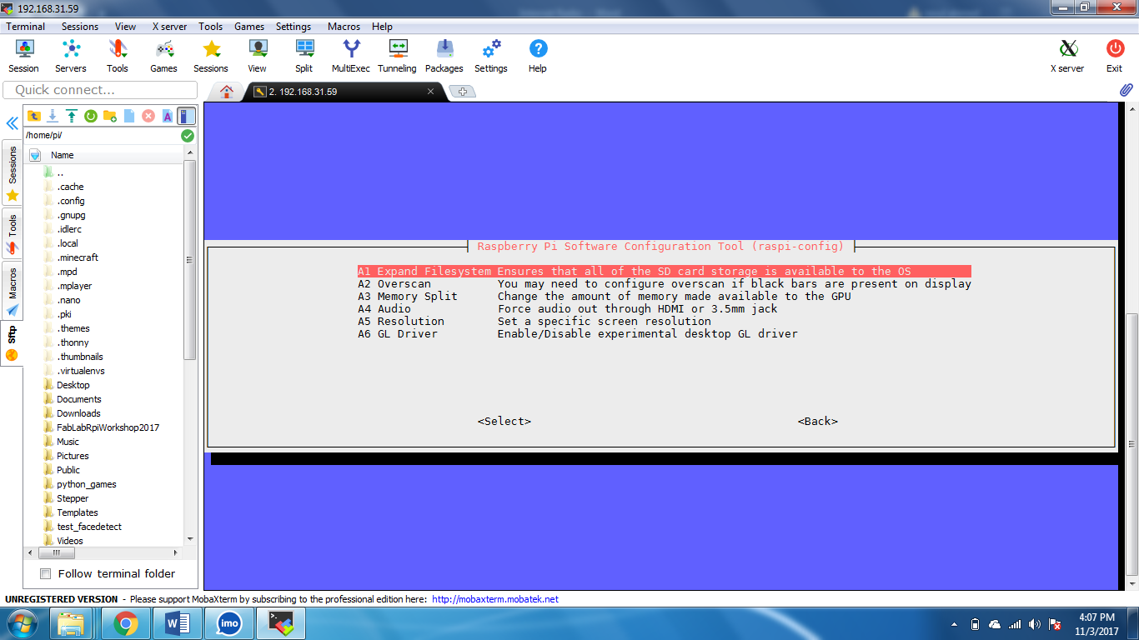

Go to line A4 (Audio) and press enter:

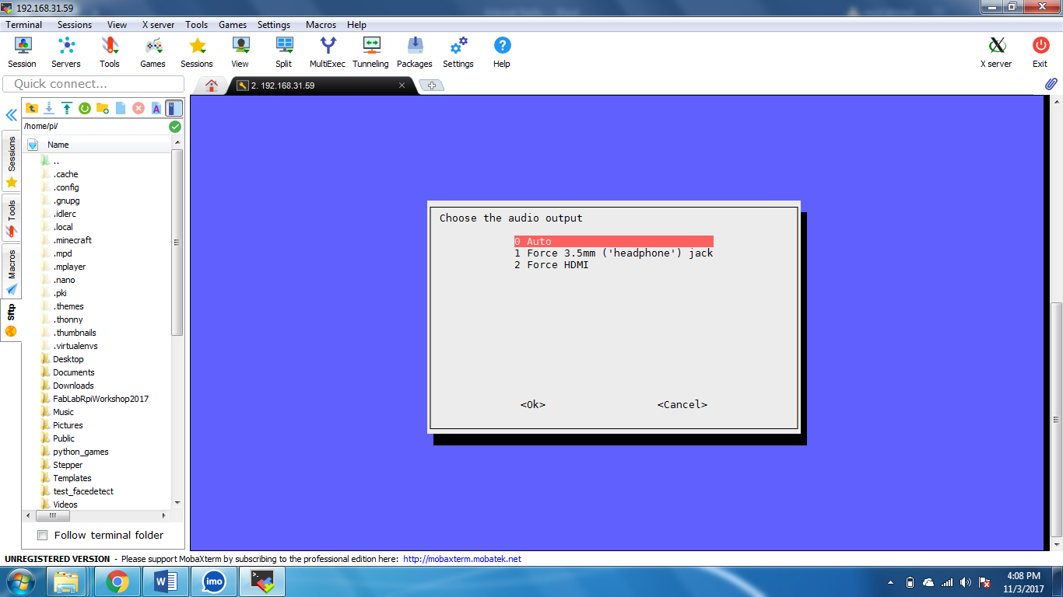

Select Audio 3.5 mm and press Enter.

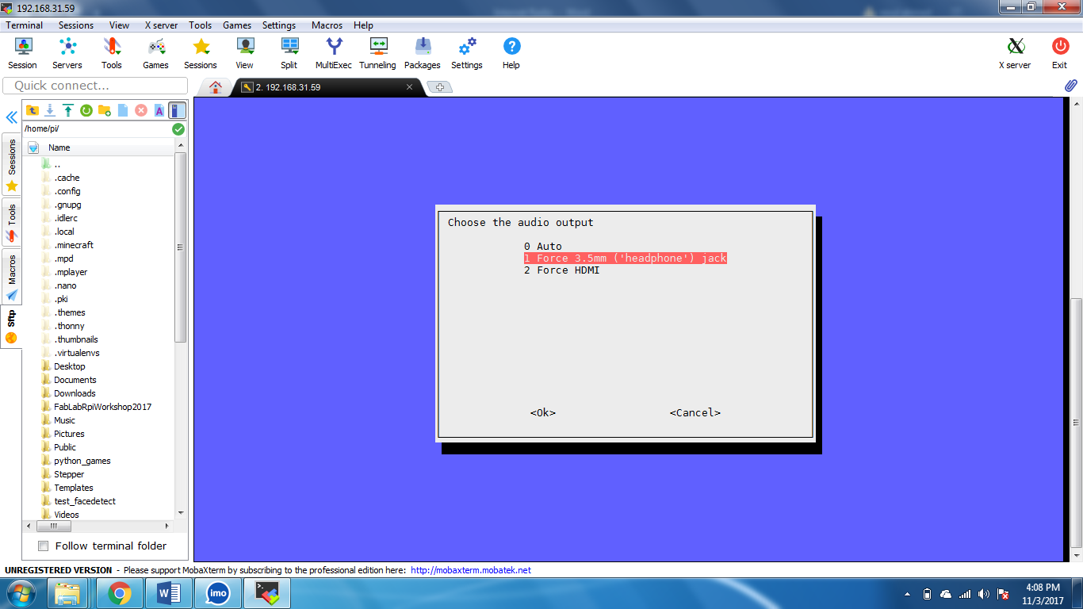

**4.5 GitHub links & Cloning/Downloading**

For Python Code go to: <https://github.com/Raselahmed825/Internet-Radio.git>

Click Clone or Download and Download ZIP file.

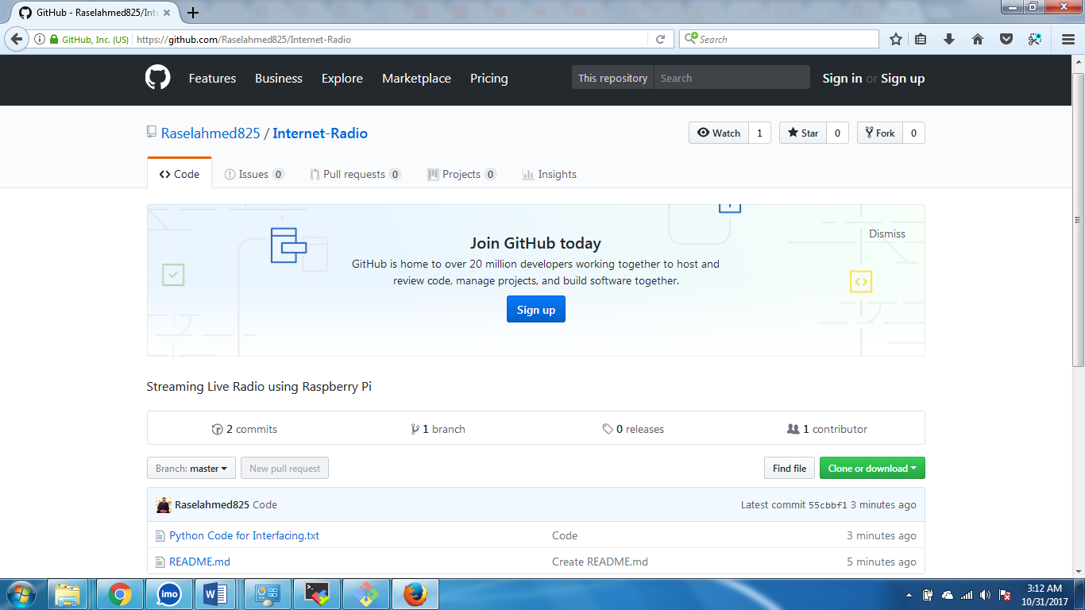

**5.0 Problems & Solutions**

**5.1 Problems**

1. Memory card crash.
2. WIFI does not work sometimes.
3. Will give less performance and heat up if powered through laptop/PC.
4. Updates sometimes crash and causes error.
5. Audio port does not work automatically.

**5.2 Solutions**

1. Memory card should be genuine & should be of class 10.
2. When the WIFI doesn’t work connect Ethernet or connect external WIFI modem.
3. Always connect it to 5V 2A to get full performance.
4. If updates crash, Reburn the memory and start newly.
5. Always go to settings and select Audio.

**6.0 Completing Radio**

**6.1 Playing and Casing**

Download the code to Raspbian and then run them.   
To add channels of your choice you need to mine new channels and then insert those into the code.

To play type:

**mpc add “channel link”.  
mpc play**  
  
To increase the volume type:

**mpc volume up**

To decrease the volume type:

**mpc volume down**

To change channel Type:

**mpc next**

To go to the prev channel type:

**mpc prev**

**7.0 Contacts**

**7.1 Email & Other links**

To get support regarding this project Contact us at:  
 Email: [Raselahmed825@gmail.com](mailto:Raselahmed825@gmail.com)  
 Facebook: fb.com/Raselahmed825

Email: [Rafikhan@usa.com](mailto:Rafikhan@usa.com)   
 Facebook: fb.com/therafikhan

Email:  
 Facebook: fb.com/an.ariyan.naim

Email:  
 Facebook: fb.com/mahbubrahman.jayan

Email:  
 Facebook: fb.com/ Eraj.K4linux

**8.0 CONCLUSION**

**8.1 Future Development**

**8.2 Conclusion**

**References**

Wikipedia.com

Google.com

Raspberrypi.org

instructables.com

********************THE END********************